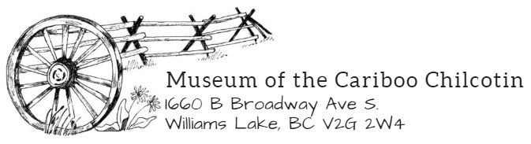

Recommendation for Deaccession

Object Accession Number:
Object Name:
Object Description:
Current Condition: GOOD FAIR POOR
Provenance/Locality:
Donor and Address:

Reason for Deaccession (check all that apply):
- Lack of significance, relevance or usefulness to Museum research, exhibition, or exhibit mission and goals.
- Outside the scope of the Museum collection policy and mandate.
- Opportunity to upgrade or reduce redundancy in the collection.
- Deterioration, damage, or alteration beyond repair/requiring excessive resources and conservation to repair.
- Proper preservation within current Museum facilities and/or resources is not possible.
- Inadequate provenance documentation that reduces significant usefulness.
- Authenticity has been discredited.
- Legality of ownership is challenged under further investigation.
- Hazardous condition that may threaten stability of other collections and/or health of personnel.
- Return to previous holder is legally required.
- Legitimate repatriation claim.
- Should not have been accessioned – is not a collection item.

Documentation: Yes No, Explain:
Attachments:
- Donor Form
- Photographs
- Catalog Record
- Other:

Recommended Disposition:
- Donate to more appropriate Institution
- Intentional destruction of damaged or hazardous objects
- Disposal of unidentified or duplicate objects
- Repurpose for educational or display use
- Give back to donor or donor’s family if legally required
- Repatriate to First Nations Community

Prepared by:
Date:

Approval:
- Museum Manager: ___________________________________________________________
Date: ___________________________________________

Approved Not Approved, Explain:

Reason for Non-Approval: ____________________________________________________________________________________________________________________________________________________________
______________________________________________________________________________

- Board of Directors/Deaccessioning Committee: ____________________________________
Date: ___________________________________________

Approved Not Approved, Explain:

Reason for Non-Approval: __________________________________________________________________________________________________________________________________________________________________________________________________________________________________________

Final Disposition of Object:
Disposition: ____________________________________________________________________
By: ___________________________________________________________________________
Date: _________________________________________________________________________
Attach Transfer Form, Receipt, or Record of Final Disposition and Witness Destruction Form.

